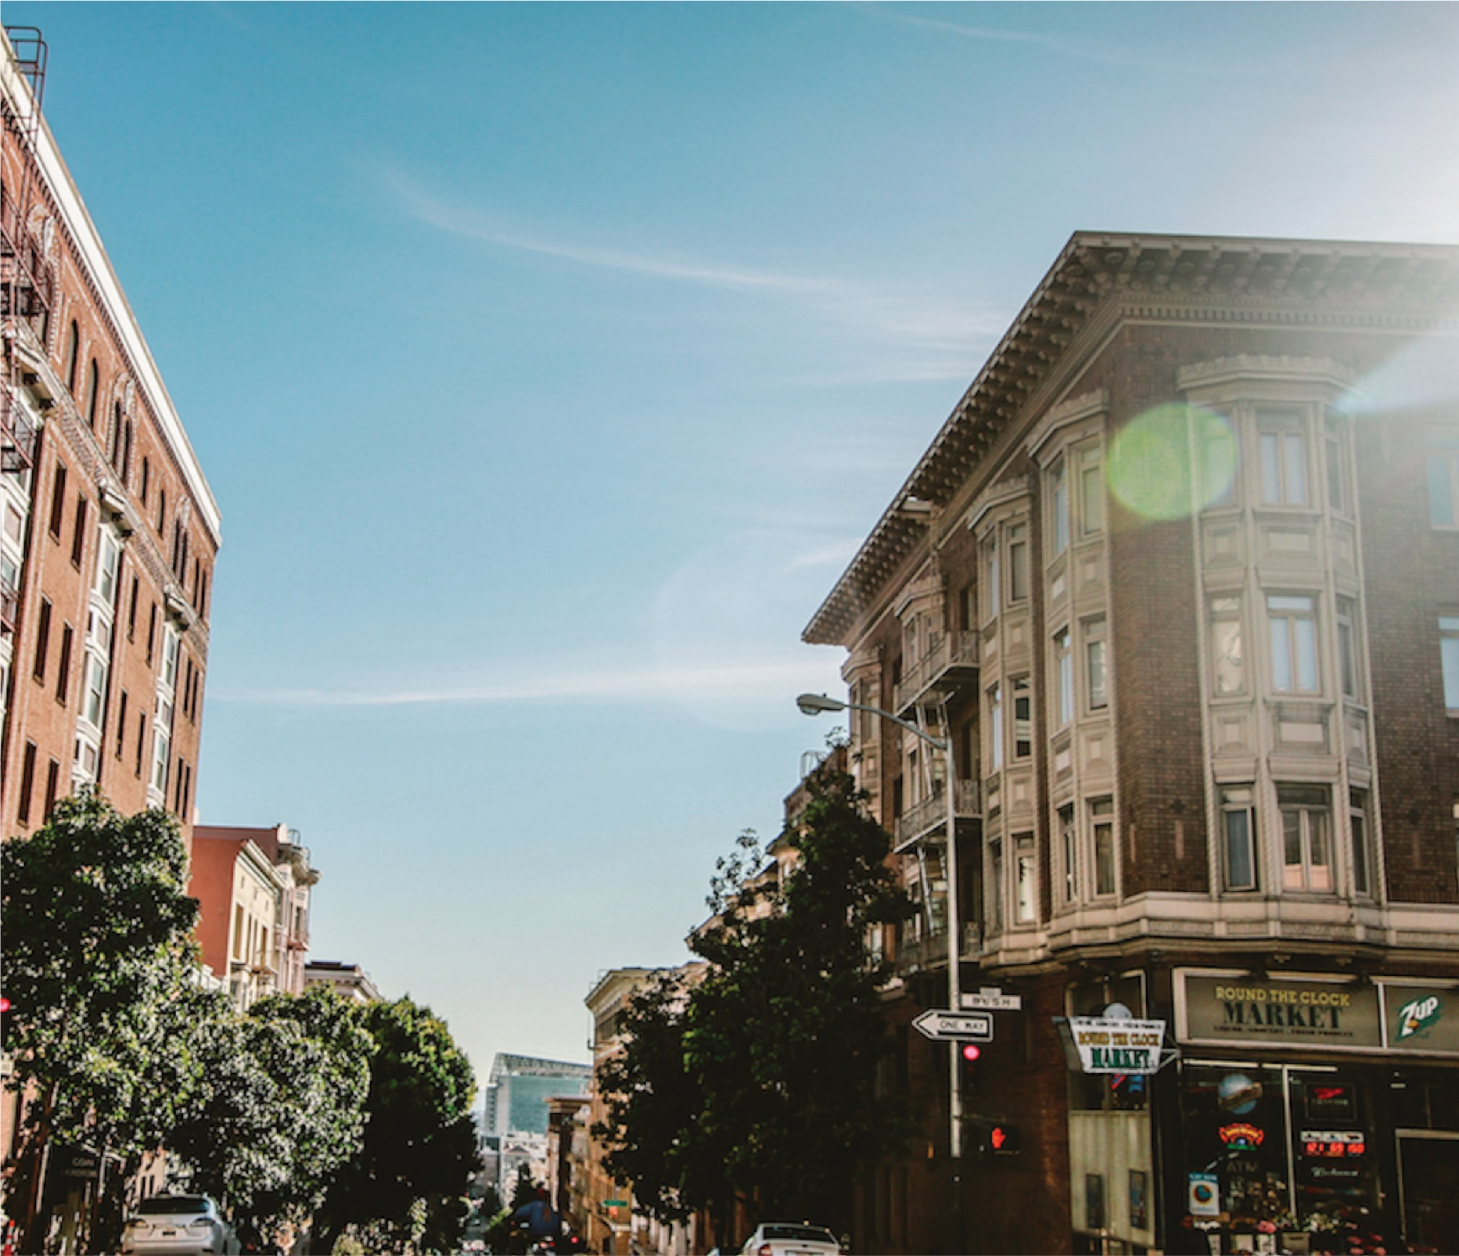

PROJECT REPORT

May 31

MATHI PAINTS
PROP:SEETHARAMAN ISWARYA MUTHU
DOOR NO:48/1B KARUPATTIYAR COMPLEX ,NAVALPATTU ROAD ,SELVAPURAM 2ND STREET TRICHY 620013
GSTIN:33AJIPI8601A1ZS


PROPOSED FINANCE:OVERDRAFT
AMOUNT:Rs10.00Lakhs
LIABILITIES:
Liabilities | FY 2025-26 | FY 2026-27 | FY 2027-28 | FY 2028-29
LIABILITIES
A. CAPITAL & RESERVES
Proprietor's Capital (Opening) | 25,16,736 | 33,00,208 | 33,00,208 | 38,33,914
Add: Net Profit for the year | 11,78,884 | 12,33,706 | 14,54,613 | 14,56,892
Less: Drawings | 3,95,412 | 7,00,000 | 8,00,000 | 8,00,000
CLOSING CAPITAL | 33,00,208 | 38,33,914 | 39,54,821 | 44,90,806
B. BORROWED FUNDS
MSME OD/CC – Canara Bank | 6,48,223 | 10,00,000 | 10,00,000 | 10,00,000
Bajaji Finance Ltd. | 5,50,539 | 4,75,539 | 3,92,000 | 3,92,000
C. CURRENT LIABILITIES
Sundry Creditors | 5,51,894 | 4,10,800 | 4,85,621 | 4,85,621
God's Account | 1,501 | 1,501 | 1,501 | 1,501
TOTAL LIABILITIES | 50,52,365 | 57,21,754 | 58,33,943 | 63,69,928

ASSET:
Assets | FY 2025-26 | FY 2026-27 | FY 2027-28 | FY 2028-29
ASSETS
A. FIXED ASSETS (Net of Dep.)
Furniture & Fittings | 3,291 | 2,962 | 2,666 | 2,399
Plant & Machinery | 4,270 | 3,843 | 3,459 | 3,113
Computer & Printer | 8,683 | 7,815 | 7,033 | 6,330
TOTAL FIXED ASSETS | 16,244 | 14,620 | 13,158 | 11,842
B. CURRENT ASSETS
Closing Stock | 43,47,543 | 49,54,196 | 50,94,696 | 58,50,420
Sundry Debtors | 4,98,990 | 5,61,887 | 5,33,037 | 3,11,614
Shop Advance | 50,000 | 50,000 | 50,000 | 50,000
Cash at Bank (KVB-CA) | 8,736 | 10,000 | 12,000 | 15,000
Cash in Hand | 34,800 | 35,000 | 35,000 | 35,000
GST ITC (CGST) | 48,026 | 48,026 | 48,026 | 48,026
GST ITC (SGST) | 48,026 | 48,026 | 48,026 | 48,026
TOTAL ASSETS | 50,52,365 | 57,21,755 | 58,33,943 | 63,69,928

MATHI PAINTS (S. ISWARYA MUTHU) – Profit & Loss Account
Door No.48/1B, Karupattiyar Complex, Navalpattu Road, Selvapuram 2nd Street, Thiruverumbur, Tiruchirappalli-620013 | GSTIN: 33AJIPI8601A1ZS
Particulars | FY 2025-26 (Actual) | FY 2026-27 (Projected) | FY 2027-28 (Projected) | FY 2028-29 (Projected)
A. INCOME
Business / Sales Income | 1,22,26,915 | 1,36,77,895 | 1,59,12,348 | 1,83,59,200
Add: Opening Stock | 39,52,312 | 43,47,543 | 49,54,196 | 50,94,696
Less: Closing Stock | 43,47,543 | 49,54,196 | 50,94,696 | 58,50,420
B. EXPENDITURE
Purchases – Goods & Services | 1,06,30,023 | 1,22,16,000 | 1,37,12,415 | 1,67,15,487
Salary Paid | 1,92,000 | 1,96,000 | 2,15,600 | 2,37,160
Power & Fuel Expenses | 1,58,405 | 1,62,000 | 1,74,960 | 1,88,957
Repair & Maintenance | 28,740 | 31,039 | 33,522 | 36,204
General Expenses | 6,842 | 7,389 | 7,981 | 8,619
Accounting Expenses | 28,500 | 28,500 | 28,500 | 28,500
Bonus Paid | 15,993 | 16,793 | 17,632 | 18,514
Bank Charges | 4,452 | 4,675 | 4,908 | 5,154
Printing Expenses | 6,842 | 7,184 | 7,543 | 7,920
Tea & Snacks | 45,415 | 47,686 | 50,070 | 52,574
Telephone Expenses | 26,400 | 27,720 | 29,106 | 30,561
Others / Miscellaneous | 2,09,500 | 2,26,260 | 2,44,361 | 2,63,910
Depreciation | 88,440 | 79,596 | 71,636 | 64,473
TOTAL EXPENDITURE | 1,14,41,552 | 1,30,50,842 | 1,45,98,235 | 1,76,58,032
NET PROFIT (Before Tax) | 11,80,594 | 12,33,706 | 14,54,613 | 14,56,892

